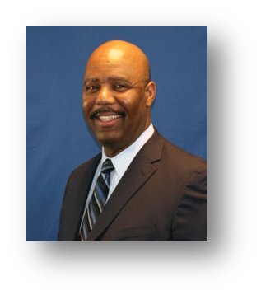
Kevin Blann
Educator
Mr. Blann earned his B.S. degree from Ashland College. Prior to joining the Ohio Public Employees’ Retirement System, Kevin spent eight years as a Financial Advisor and Guided Portfolio Manager with the Columbus office of Smith Barney. Additionally, he has 13 years of science and research experience with Battelle Memorial Institute and The United States Army’s Radiologic Inorganic Chemistry Division. Mr. Blann is currently an Education Representative at OPERS. He travels throughout the state of Ohio conducting individual meetings and group seminar presentations to explain OPERS to state employees and employers.

